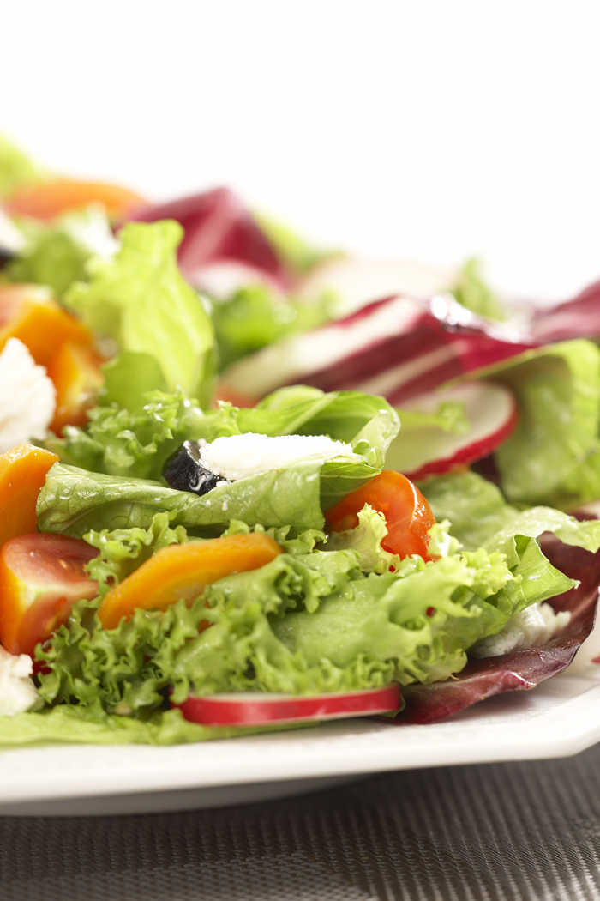
2009 Cape Girardeau WBA Annual Banquet
Thursday March 19, 2009 6:00 pm
Cape Girardeau VFW

Menu
(Prepared and Served by the VFW Ladies Auxiliary)
Fried Chicken
Pulled Pork
Baked Potato
Green Beans
Salad
Roll/Bread

$10.00/person
$8.00/senior citizen

At the banquet we will be:
*Presenting Awards and Tournament Money*
*Electing State Delegates*
*Electing 5 board directors and the Vice-President*
*Video Entertainment*
*Door Prizes*

